HTML Assignment

1. Create a Basic Web Page

Write the HTML code to create a simple web page with a title “My First Page”, a heading, a

paragraph, and a horizontal line.

<!DOCTYPE html>

<html>

<head>

  <title>My First Page</title>

</head>

<body>

  <h1>Welcome to My First Page</h1>

  <p>This is a simple paragraph on my very first web page.</p>

  <hr>

</body>

</html>

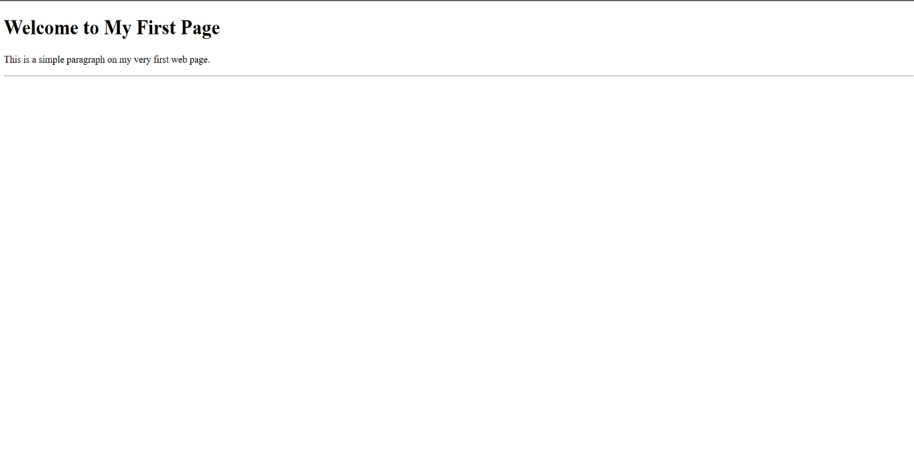

2. Build a Personal Profile Page

Create an HTML page that includes your name (using <h1>), a short biography (using <p>), a list of

your hobbies (using <ul>), and a photo of yourself (using <img>).

<!DOCTYPE html>

<html>

<head>

  <title>My Profile</title>

</head>

<body>

  <!-- Name -->

  <h1>Sanjay</h1>

  <!-- Photo -->

  <img src="profile.jpg" alt="Profile Photo" width="200">

  <!-- Biography -->

  <h2>About Me</h2>

  <p>Hello! I'm Sanjay, a web development enthusiast who loves creating simple and clean websites. I enjoy learning new technologies and turning ideas into digital reality.</p>

  <!-- Hobbies -->

  <h2>My Hobbies</h2>

  <ul>

    <li>Reading books</li>

    <li>Playing cricket</li>

    <li>Coding and building websites</li>

    <li>Traveling</li>

  </ul>

</body>

</html>

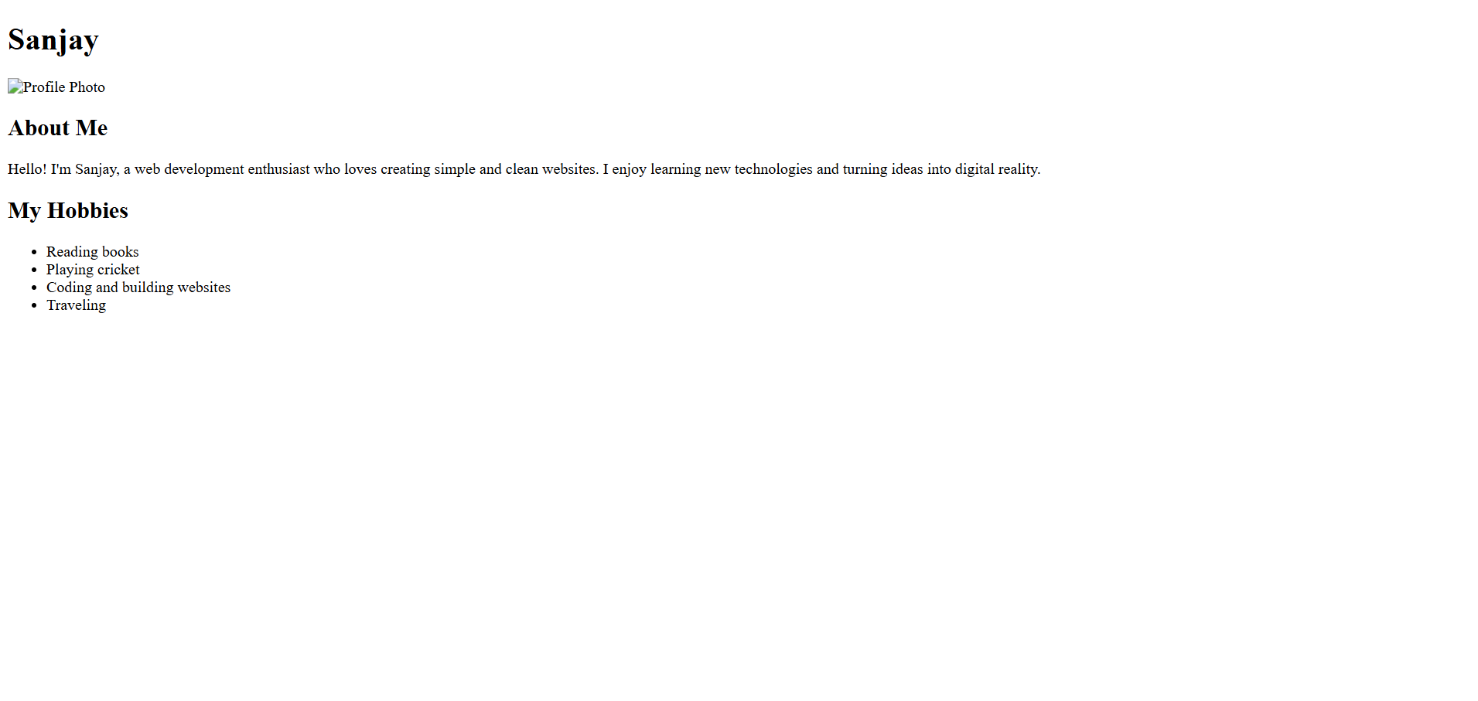

3. Navigation Menu using Links

Design a navigation bar using anchor (<a>) tags that link to five different sections of a webpage:

Home, About, Services, Portfolio, and Contact.

<!DOCTYPE html>

<html lang="en">

<head>

    <meta charset="UTF-8">

    <meta name="viewport" content="width=device-width, initial-scale=1.0">

    <title>Website Navigation</title>

    <style>

        /\* Basic styling for the navigation \*/

        nav {

            background-color: #333;

            padding: 15px 0;

            text-align: center;

        }

        nav a {

            color: white;

            text-decoration: none;

            padding: 10px 20px;

            margin: 0 5px;

            font-family: Arial, sans-serif;

            font-size: 16px;

        }

        nav a:hover {

            background-color: #555;

            border-radius: 4px;

        }

    </style>

</head>

<body>

    <nav>

        <a href="#home">Home</a>

        <a href="#about">About</a>

        <a href="#services">Services</a>

        <a href="#portfolio">Portfolio</a>

        <a href="#contact">Contact</a>

    </nav>

    <!-- Page sections that the navigation links to -->

    <section id="home" style="height: 100vh; padding: 20px;">

        <h1>Welcome to Our Website</h1>

        <p>This is the home section.</p>

    </section>

    <section id="about" style="height: 100vh; padding: 20px; background-color: #f0f0f0;">

        <h1>About Us</h1>

        <p>Learn more about our company and team.</p>

    </section>

    <section id="services" style="height: 100vh; padding: 20px;">

        <h1>Our Services</h1>

        <p>Discover what we can do for you.</p>

    </section>

    <section id="portfolio" style="height: 100vh; padding: 20px; background-color: #f0f0f0;">

        <h1>Portfolio</h1>

        <p>View our previous work and projects.</p>

    </section>

    <section id="contact" style="height: 100vh; padding: 20px;">

        <h1>Contact Us</h1>

        <p>Get in touch with our team.</p>

    </section>

</body>

</html>

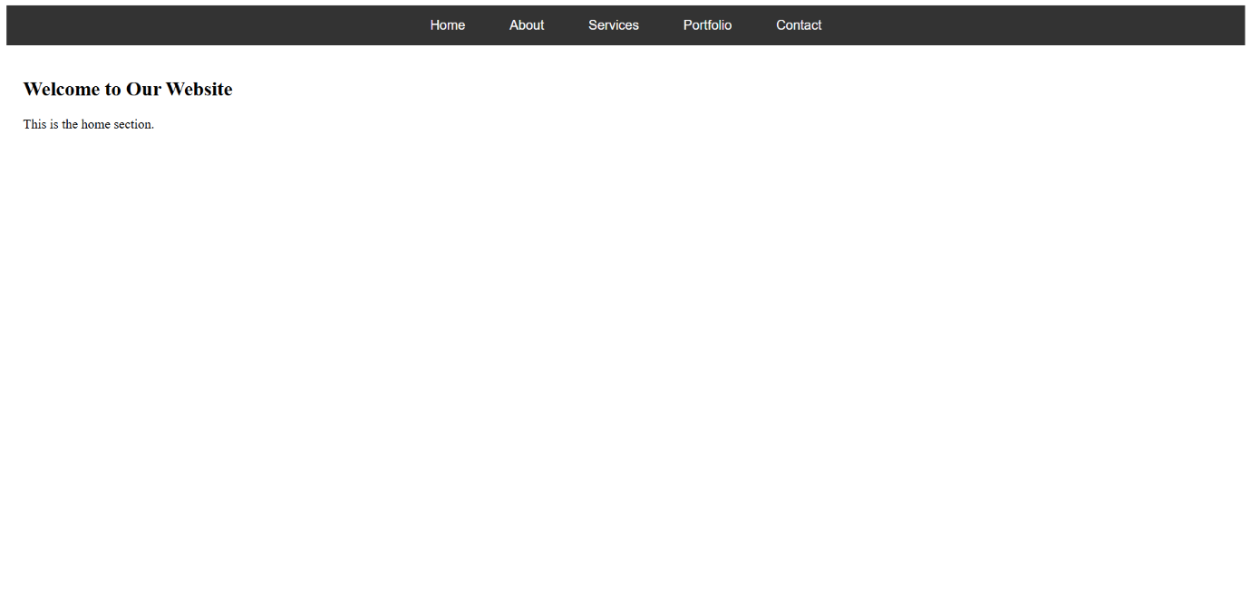

4. Student Information Table

Create an HTML table displaying student data: Name, Roll No, Department, and Marks in 3

subjects. Include column headers using <th>.

<!DOCTYPE html>

<html>

<head>

    <title>Student Information Table</title>

    <style>

        table {

            width: 70%;

            border-collapse: collapse;

            margin: 20px auto;

        }

        th, td {

            border: 1px solid #444;

            padding: 10px;

            text-align: center;

        }

        th {

            background-color: #f2f2f2;

        }

        h2 {

            text-align: center;

        }

    </style>

</head>

<body>

    <h2>Student Information Table</h2>

    <table>

        <tr>

            <th>Name</th>

            <th>Roll No</th>

            <th>Department</th>

            <th>Subject 1 Marks</th>

            <th>Subject 2 Marks</th>

            <th>Subject 3 Marks</th>

        </tr>

        <tr>

            <td>KIRAN</td>

            <td>101</td>

            <td>Computer Science</td>

            <td>85</td>

            <td>90</td>

            <td>88</td>

        </tr>

        <tr>

            <td>SUPRITH</td>

            <td>102</td>

            <td>Electronics</td>

            <td>78</td>

            <td>84</td>

            <td>80</td>

        </tr>

        <tr>

            <td>SANJITH</td>

            <td>103</td>

            <td>Mechanical</td>

            <td>92</td>

            <td>89</td>

            <td>95</td>

        </tr>

    </table>

</body>

</html>

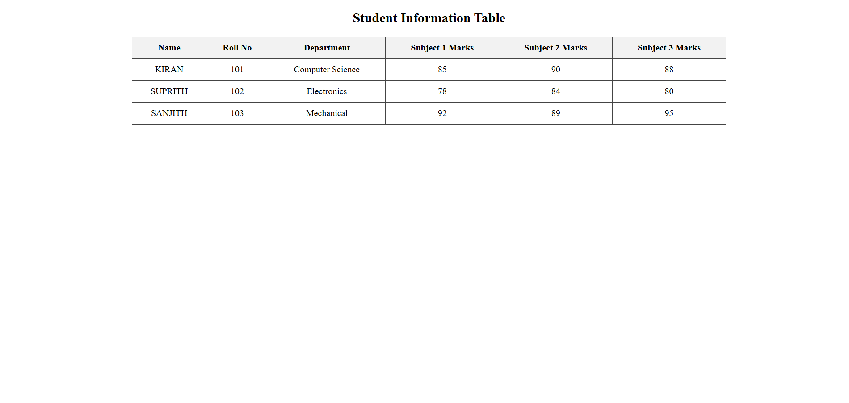

5. Design a Feedback Form

Write HTML code for a feedback form with input fields for name, email, rating (1–5 using radio

buttons), and a comment box. Add a submit button.

<!DOCTYPE html>

<html>

<head>

  <title>Feedback Form</title>

</head>

<body>

  <h2>Feedback Form</h2>

  <form>

    <!-- Name -->

    <label for="name">Name:</label><br>

    <input type="text" id="name" name="name" required><br><br>

    <!-- Email -->

    <label for="email">Email:</label><br>

    <input type="email" id="email" name="email" required><br><br>

    <!-- Rating -->

    <label>Rating (1 to 5):</label><br>

    <input type="radio" id="rate1" name="rating" value="1" required>

    <label for="rate1">1</label>

    <input type="radio" id="rate2" name="rating" value="2">

    <label for="rate2">2</label>

    <input type="radio" id="rate3" name="rating" value="3">

    <label for="rate3">3</label>

    <input type="radio" id="rate4" name="rating" value="4">

    <label for="rate4">4</label>

    <input type="radio" id="rate5" name="rating" value="5">

    <label for="rate5">5</label><br><br>

    <!-- Comment Box -->

    <label for="comments">Comments:</label><br>

    <textarea id="comments" name="comments" rows="4" cols="40"></textarea><br><br>

    <!-- Submit Button -->

    <input type="submit" value="Submit Feedback">

  </form>

</body>

</html>

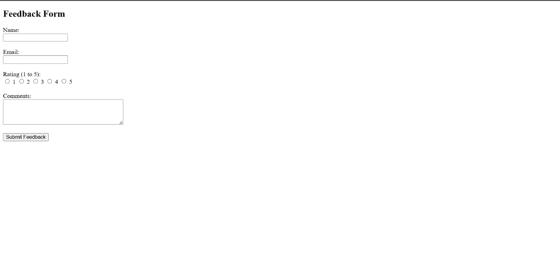

6. Semantic Layout Page

Design a basic webpage layout using semantic elements like <header>, <nav>, <section>,

<article>, <aside>, and <footer>.

<!DOCTYPE html>

<html>

<head>

  <title>Semantic Layout Example</title>

  <style>

    body {

      font-family: Arial, sans-serif;

      margin: 0;

    }

    header, nav, section, article, aside, footer {

      padding: 15px;

      margin: 10px;

    }

    header {

      background-color: #4CAF50;

      color: white;

      text-align: center;

    }

    nav {

      background-color: #f2f2f2;

    }

    section {

      display: flex;

    }

    article {

      flex: 2;

      background-color: #e6f7ff;

    }

    aside {

      flex: 1;

      background-color: #f9f9f9;

    }

    footer {

      background-color: #333;

      color: white;

      text-align: center;

    }

  </style>

</head>

<body>

  <header>

    <h1>My Website</h1>

  </header>

  <nav>

    <a href="#">Home</a> |

    <a href="#">About</a> |

    <a href="#">Blog</a> |

    <a href="#">Contact</a>

  </nav>

  <section>

    <article>

      <h2>Main Article</h2>

      <p>This is the main content of the page, placed inside an article tag.</p>

    </article>

    <aside>

      <h3>Related Links</h3>

      <p>This is some additional content or links, placed inside an aside tag.</p>

    </aside>

  </section>

  <footer>

    <p>&copy; 2025 My Website. All rights reserved.</p>

  </footer>

</body>

</html>

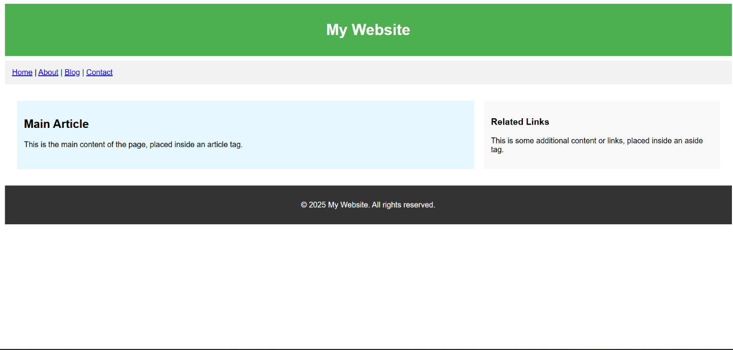

7. Multimedia Embedding

Embed an audio clip and a video clip on a web page. Use <audio> and <video> tags with proper

controls.

<!DOCTYPE html>

<html>

<head>

  <title>Multimedia Embedding</title>

</head>

<body>

  <h1>Multimedia Example</h1>

  <h2>Audio Clip</h2>

  <p>Listen to the audio below:</p>

  <audio controls>

    <source src="sample-audio.mp3" type="audio/mpeg">

    Your browser does not support the audio element.

  </audio>

  <h2>Video Clip</h2>

  <p>Watch the video below:</p>

  <video width="480" controls>

    <source src="sample-video.mp4" type="video/mp4">

    Your browser does not support the video tag.

  </video>

</body>

</html>

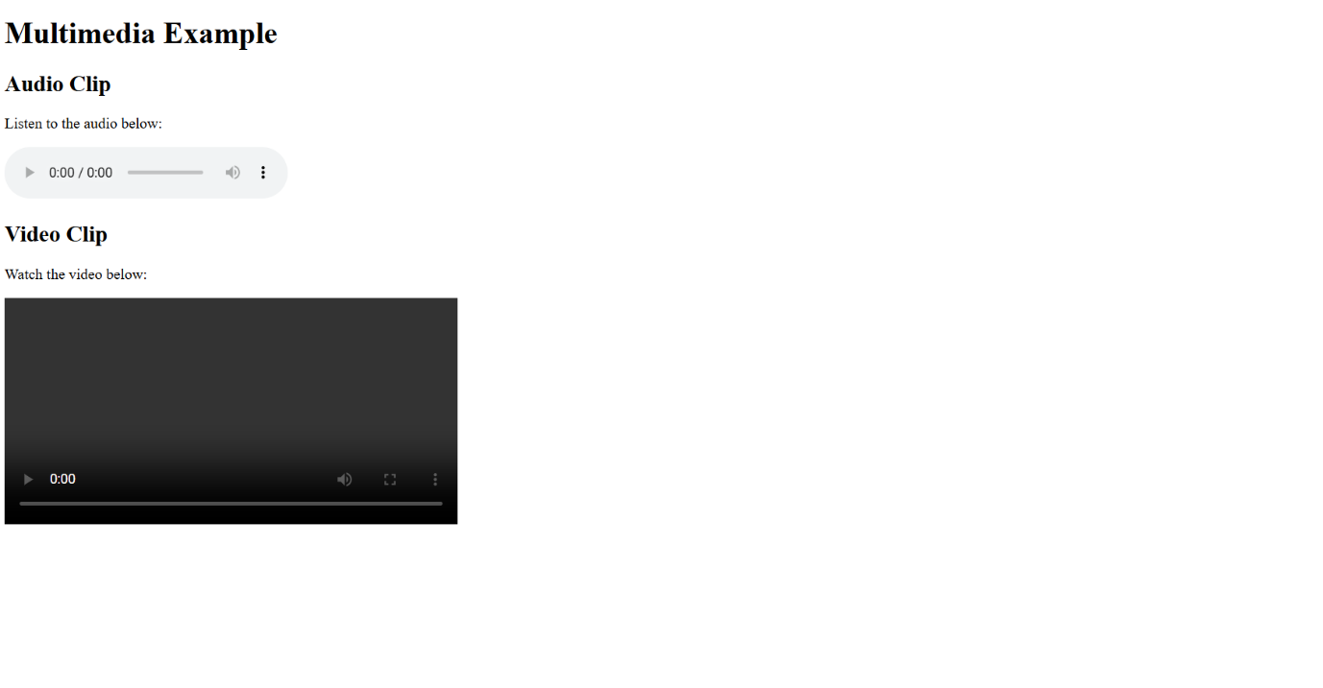

8. Responsive Design Practice

Use the viewport meta tag and write basic CSS inside a <style> tag to make a web page look good

on both mobile and desktop screens.

<!DOCTYPE html>

<html>

<head>

  <title>Responsive Web Page</title>

  <!-- Viewport Meta Tag for Responsive Design -->

  <meta name="viewport" content="width=device-width, initial-scale=1.0">

  <style>

    body {

      font-family: Arial, sans-serif;

      margin: 20px;

      padding: 0;

    }

    header {

      background-color: #4CAF50;

      color: white;

      padding: 15px;

      text-align: center;

    }

    .content {

      padding: 15px;

    }

    /\* Responsive layout for smaller screens \*/

    @media (max-width: 600px) {

      header {

        font-size: 20px;

        padding: 10px;

      }

      .content {

        font-size: 16px;

      }

    }

  </style>

</head>

<body>

  <header>

    <h1>My Responsive Website</h1>

  </header>

  <div class="content">

    <p>This webpage adjusts its layout for different screen sizes using responsive design techniques.</p>

    <p>Resize the browser window or open it on a mobile device to see the effect.</p>

  </div>

</body>

</html>

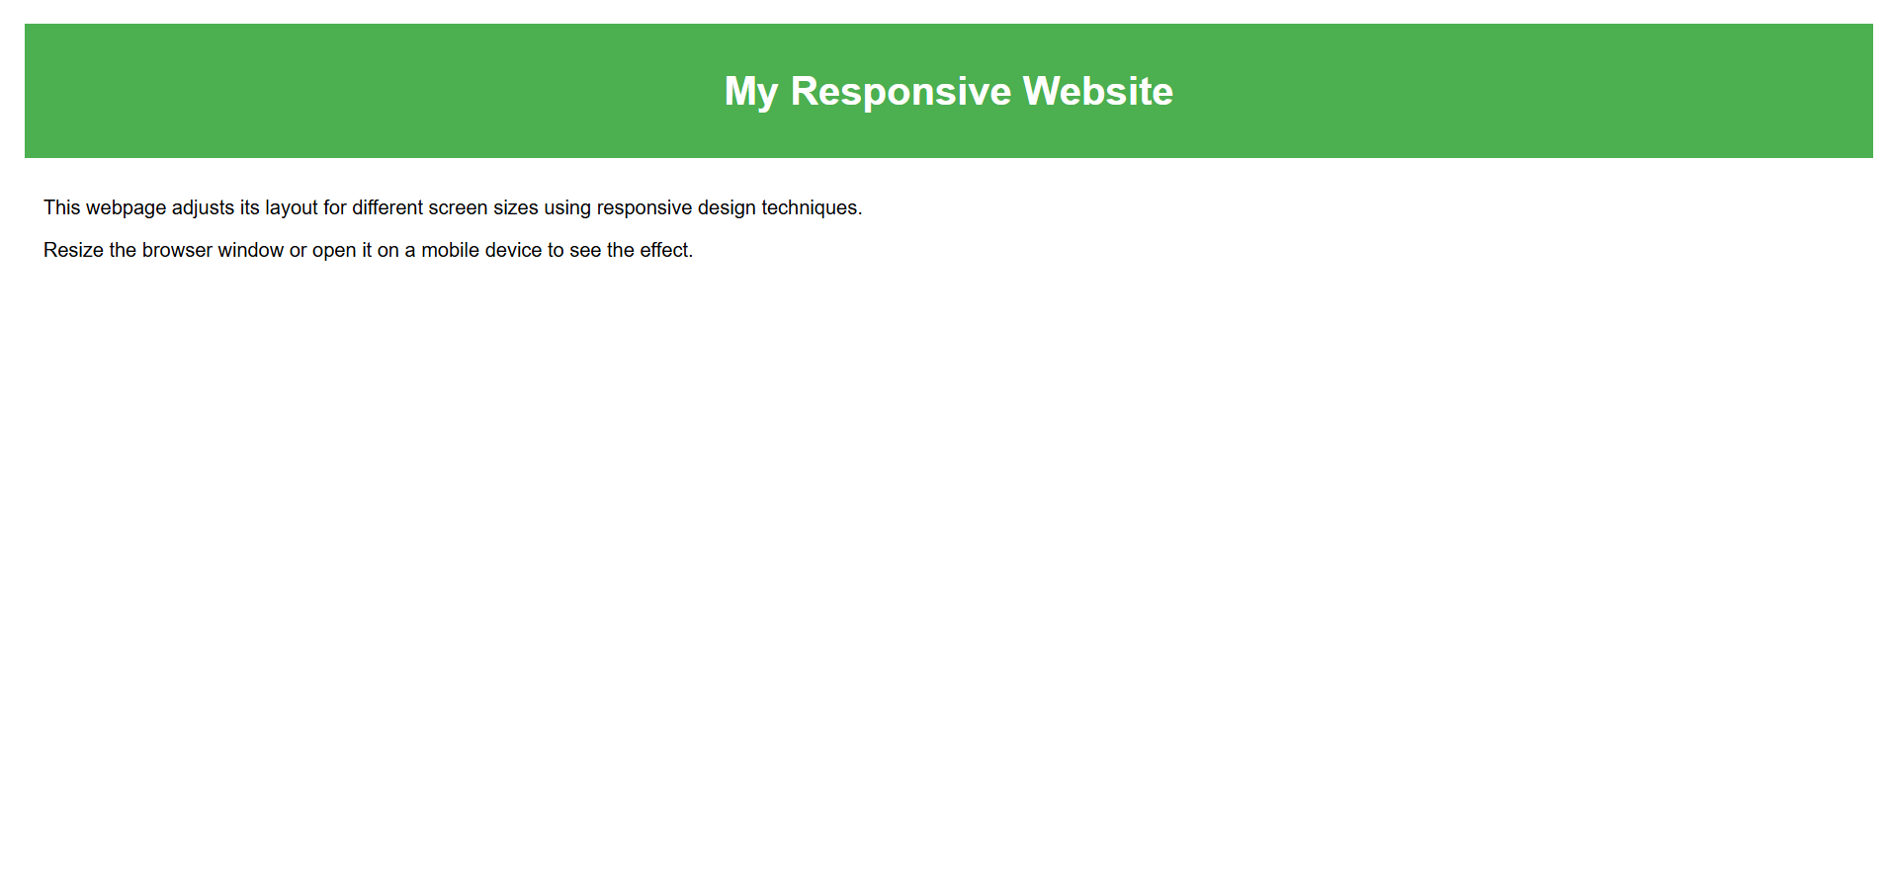

9. Use of Iframes

Create a web page that displays another website (like Wikipedia) inside an <iframe>. Add headings

and descriptions around it.

<!DOCTYPE html>

<html>

<head>

  <title>Iframe Example</title>

</head>

<body>

  <h1>Embedded Website Example</h1>

  <p>Below is an embedded view of Wikipedia using an iframe:</p>

  <iframe src="https://www.wikipedia.org" width="100%" height="500px" title="Wikipedia">

    Your browser does not support iframes.

  </iframe>

</body>

</html>

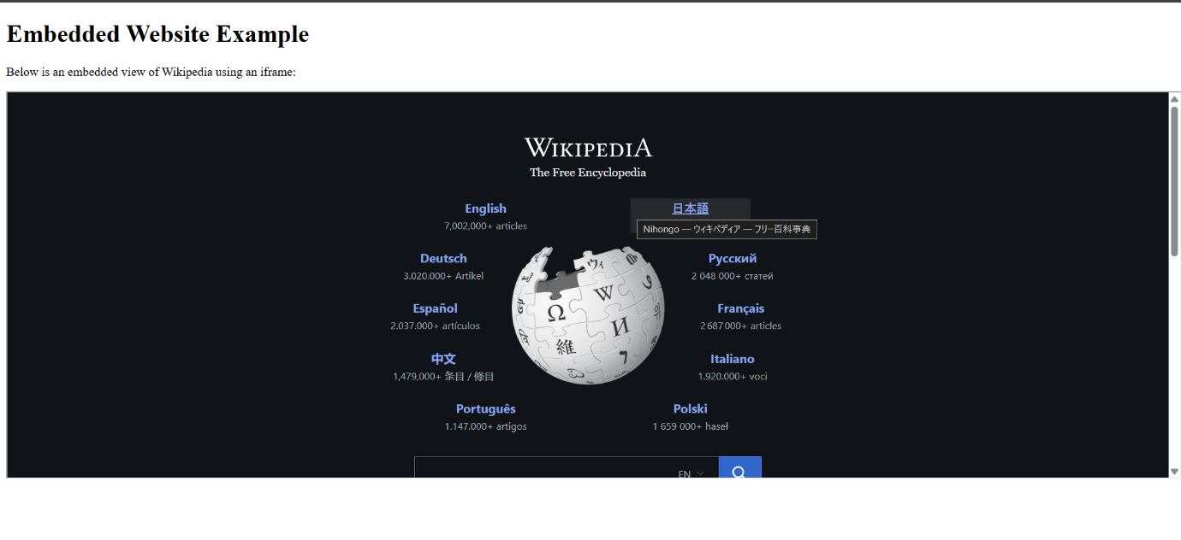

10. Form Validation Practice

Create an HTML form for user registration with fields: Username, Password, Email, and Phone

Number. Use appropriate input types and include required and pattern attributes for validation.

<!DOCTYPE html>

<html>

<head>

  <title>User Registration Form</title>

</head>

<body>

  <h2>User Registration</h2>

  <form>

    <!-- Username -->

    <label for="username">Username:</label><br>

    <input type="text" id="username" name="username" required><br><br>

    <!-- Password -->

    <label for="password">Password:</label><br>

    <input type="password" id="password" name="password" required

           pattern=".{6,}" title="Password must be at least 6 characters"><br><br>

    <!-- Email -->

    <label for="email">Email:</label><br>

    <input type="email" id="email" name="email" required><br><br>

    <!-- Phone Number -->

    <label for="phone">Phone Number:</label><br>

    <input type="tel" id="phone" name="phone" required

           pattern="[0-9]{10}" title="Enter a 10-digit phone number"><br><br>

    <input type="submit" value="Register">

  </form>

</body>

</html>

